ASSIGNMENT 1

Part 2

Minh Nguyen

104309099

COS10026 – COMPUTER TECHNOLOGY INQUIRY PROJECT

Swinburne University of Technology

# Introduction

## Outline

In this assignment, the PHP language has been implemented into the web pages to minimize the code and to improve the security of the data. Besides, our team added more features to fix some errors, which have been shown by my tutor to enhance users' experience and adapt SQL to my project to store and protect our data, which helps maintain the integrity of the webpages.

## Objective of report

The report aims to give the reader a brief overview of the newly added features, new web pages, and how PHP and SQL have been implemented in our project. It also helps the user visualize the role of each person in our team in building up this project. In addition, the reader can see how we have made use of our knowledge and our research to build up the projects.

## Outline

Introduction 2

Outline 2

The objective of Report 2

Website 3

Website introduction 3

Technical details 9

Innovative features 9

Security of the website 10

Contribution 12

Reflection and Discussion 12

Conclusion 13

# Website

## Website introduction

**Fixing previous errors and preparation for PHP file**

|  |
| --- |
|  |
|  |

*Apply page*

For the Apply page, I have added asterisks, as suggested by my tutor, to illustrate better the field that the applicants need to fill in. Also, I add the ' novalidate = "novalidate" ' line in this HTML file to prepare for the testing of the PHP processEOI file.

For the About page, I have put all the personal information of each team member into the table to make the style look smooth and better demonstrate the personalities of our team. I also changed some of the features in the CSS file to suit my change on this page.

For the header of the webpages, my friend Adrien has changed some features based on some recommendations from our tutor to look better.

I also have placed the header, footer, and menu into files with .inc extension based on the requirement of the assignment and created a settings PHP file to store all the data needed to gain access to our database like the username, the password, and the name of the database. Also, I changed the HTML into a PHP file to include the .inc extension files.

|  |
| --- |
|  |
|  |

*About page*

|  |
| --- |
|  |
|  |

*The header of the webpages*

**ProcessEOI**

This is the back-end page where all the validated fields from the application form replaced the input validation in the previous HTML file. If there is any error, like a field has not been filled in or has filled in incorrect format, the page will send a message indicating which types of data field should be fixed, and when all the necessary data has been correctly filled in, it will be uploaded to the database, and the page will send a message indicating that the application process has succeeded.

PHP mainly used on this page is to validate and process the input and connect to the database. If the table needs to be created, the processEOI page will create a new table using the 'CREATE TABLE IF NOT EXIST' line and store the data with the data types and the format required in this assignment.

After the data has been stored in the database, the manager file will be used for sorting and reading the data from the database.

**Manager**

*Manager page*

This is the page where the authorized user can query the database to read the applicants' information, make the queries of the EOI table, and return appropriate results. With the use of small forms, for each query, there is a distinction form to take out the data from the database. Many mysqli_query() and mysqli_fetch_assoc() were used to create queries and take the information from the database, then display it with PHP and HTML.

Besides, there are features to delete EOIs with the job reference number and change the status of EOIs, which have been stated in the processEOI file.

**Enhancement**

|  |
| --- |
|  |
|  |

*Enhancements 2 page*

For this assignment, I have added some features relating to the job description page. Instead of dynamically storing it in an HTML file, I have put the description in the database and printed it out using PHP. This enhancement has two significant advantages: The description can be easily added by directly inserting information into the database instead of writing tens of lines for each job, which saves time in developing the website and time to fix errors since you need to modify the data in the database. In addition, the integrity and security of the website can be maintained since when you change the data, the design and the flow of the website remain unchanged. It is very different from changing a line in an HTML file, which sometimes can even lead to some other bugs that take forever to fix, and you also need to change the CSS file along with the HTML one.

In addition, my friend Adrien has made a login and logout page to control access to the manager page to enhance security and avoid unauthorized access. If the users fill in incorrect details or do not fill in any information, an error message will be sent. When the users close the browser, they will be automatically logged out, and they have to log in again, but they do not need to re-authenticate themselves.

## Technical details

There are many technical details being included in the website. The first one is full-stack technologies when we use HTML CSS to create the user interface and a server-side programming language like PHP to build the back end of your site. Besides, we use a relational database such as MySQL for data storage and data integrity and implement delete or change status for data management. We also apply responsive design as an enhancement in the previous assignment to ensure it works well on various devices and screen sizes by utilizing media queries in your CSS for responsive design. For this assignment, we have a login and logout page for user authentication to control access to specific features or content.

## Before submitting our assignment, we will test our website across different browsers and devices to ensure cross-browser compatibility and use debugging tools to identify and fix issues. It will ensure that no significant errors may happen when the website interface and the server-side part are running.

## Innovative features

For this assignment, my group had some innovative features that were difficult for us at first. However, my team has researched PHP's in-built library and SQL commands, which are suitable to be used in the current context. Our team has added the store of the job description in SQL and a login and logout page for the manager page.

For the first feature, I used the database to store the job description and print it using PHP, which helps save time in changing information and maintain the integrity of the web pages. For the second one, my friend Adrien has implemented a login and logout page for the manager page to enhance the security of the manager page.

# Security of the website

In our PHP code, we validate and sanitize user inputs and escape output data to prevent XSS attacks by using functions like htmlspecialchars or sanitise_input($_POST) to sanitize user-generated content before displaying it.

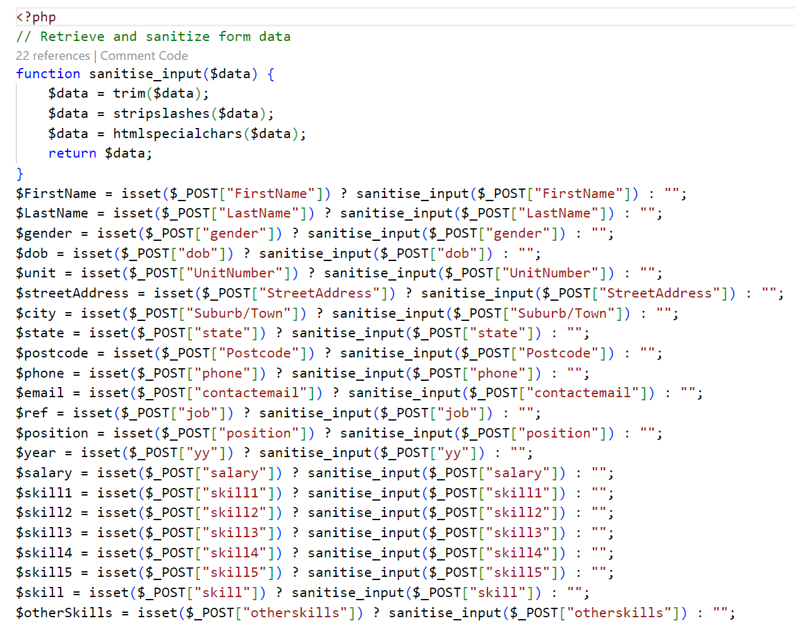

*Server-side sanitization*

Besides, we have implemented strict input validation for all user inputs by using server-side validation to check data integrity and reject any input that does not meet the required criteria. The users can know which field they need to fill in or fix by the errors displayed when the 'submit' or 'login' buttons are clicked.

*Server-side validation*

In addition, we implement a secure authentication system and ensure that users are adequately authenticated before allowing them access to specific features. Also, we enforce proper access control in your PHP code to ensure that users are assigned appropriate roles and permissions.

*Login and logout page*

# Contribution

Compared to the previous assignment, I have contributed more due to more required work. I contribute my ideas, fix minor errors in their work, and assign my teammates which part they need to do.

For my part, I have done my work sooner than others so that I can send files and they can start their part. I also remind them about the project regularly so that they will remember to do it and ask them to check the rubric regularly to make sure their work matches all the requirements in the rubric. After all, I have been involved in checking the code based on the rubrics to make the project built based on the rubrics as close as possible.

Furthermore, I have edited the code for others to delete the navbar and the footer and create files .inc to minimize the code and match the requirements and do the processEOI page. I also create the table on the MySQL server, and my teammates will help me check the work before submitting it to Canvas.

# Reflection and Discussion

Due to our teammates having many assignments along with this assignment, communication is only made when necessary so that we can save time and focus on our work. In the first assignment, we finished the work ahead of schedule, but we also made some minor errors, so in this assignment, we try to fix the errors from the previous one and avoid as many as possible. If I have time to improve our website, I will improve the user interface to make it more colorful and has more exciting features. I will also improve the PHP code for validating the information to make the collected data more accurate.

In this project, there are still issues related to security, precisely the applicants' details when there are many types of attack, and we only apply some protected methods to prevent the common attacks such as input validation or access control. In the future, we may research the attack methods and how to prevent them. If we cannot maintain the security of the data, the website can be hacked, and all the personal information can be lost and sold to a third party for inappropriate use. Protecting user data is an essential part of the project, so maintaining the security of this information is crucial for the users' experience.

# Conclusion

In conclusion, my team has implemented crucial features to enhance security and the interface of the website so that the personal details of the applicants are safe and the experience is much smoother. This project has been a valuable experience for our team since it helps enhance our teamwork and time management skills, and it provides opportunities to make use of our knowledge, which helps us a lot in our future careers.